January 2021

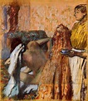
1 The piece 'After the Bath, Woman drying herself' was a composition from which French impressionist?
a) Edgar Degas b) Picasso c) Andre Derain
Answer... Degas

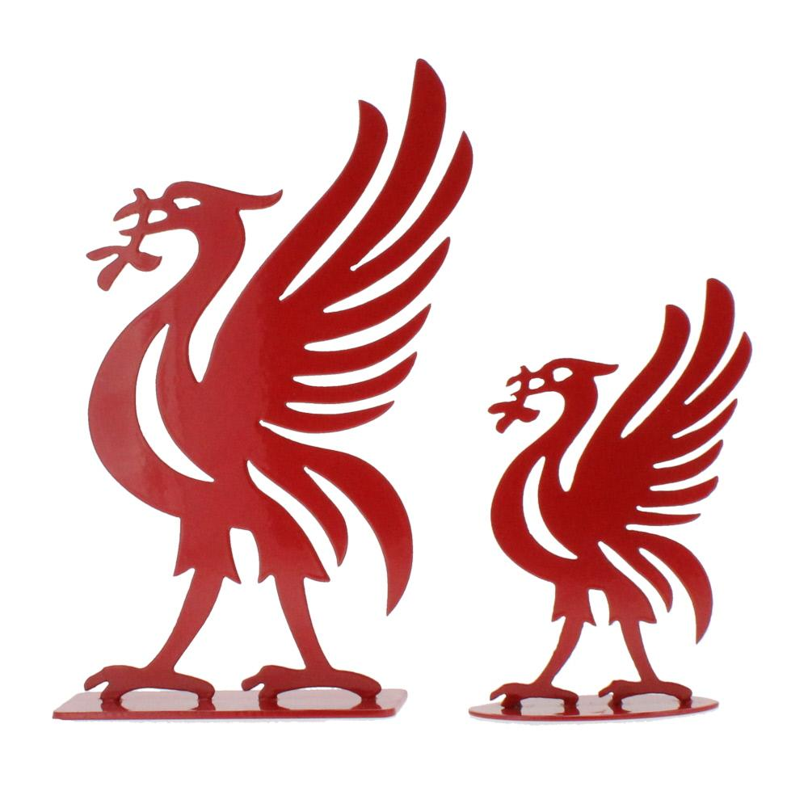

2 Where would you find these iconic birds home?

Answer Top of the Liver Buildings , Liverpool

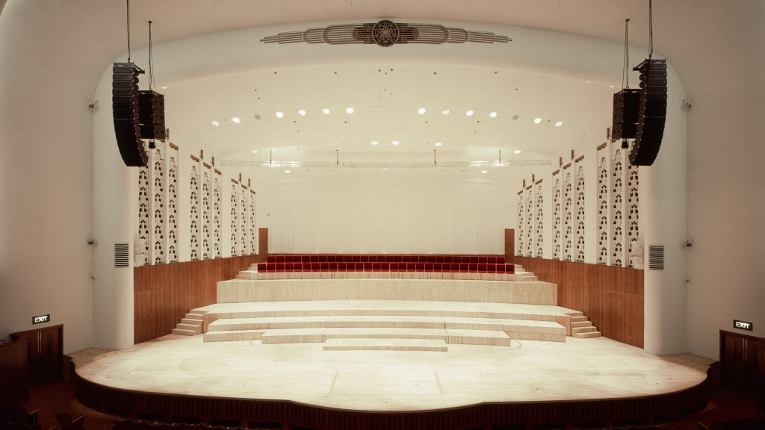

3 What style of architecture is Liverpool Philharmonic Hall?
for additional brownie point , who was the firm who
did relativity recent renovation?

Answer Art Deco Caruso St. John’s

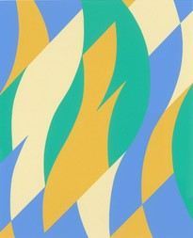

4 Which modern day female artist did this colourful work?

Answer Bridget Riley
5 Which famous Liverpool photographer lived in Rodney street ?
One of our first group visits?

Answer Chambray Hardman

6 One of my favourite artistic styles, What's it known as?

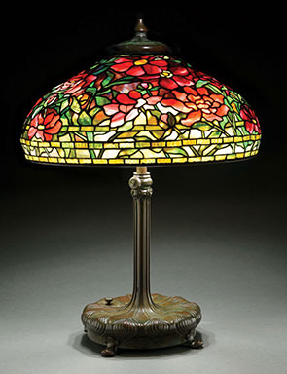
Answer Art Nouveau

7 What would you need to thin oil paint?
Answer Linseed Oil

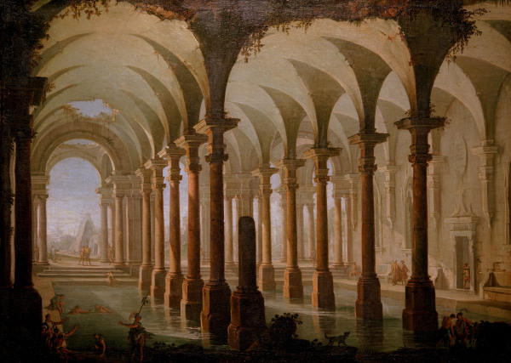
8 This was on University Challenge this week.

Name of artist please?

Answer Pannini

9 what colour would you create if mixing
red and black?

Answer Maroon


10 what is the artistic term for this mix / shape of colours ?

Answer . Colour wheel

