November 27th Art Quiz PDF

Hi Everyone,
as these quiz questions getting are slightly more challenging, I am adding some subtle, clues so read the question carefully! as they say in school.
The answers in the question. Good luck.

1 Fill in the blanks
.
The University of …….museum dedicated to William Hunter is the oldest museum in ………..
It covers the Hunterian Museum, the Hunterian Art Gallery, the Mackintosh House,

Where is It?
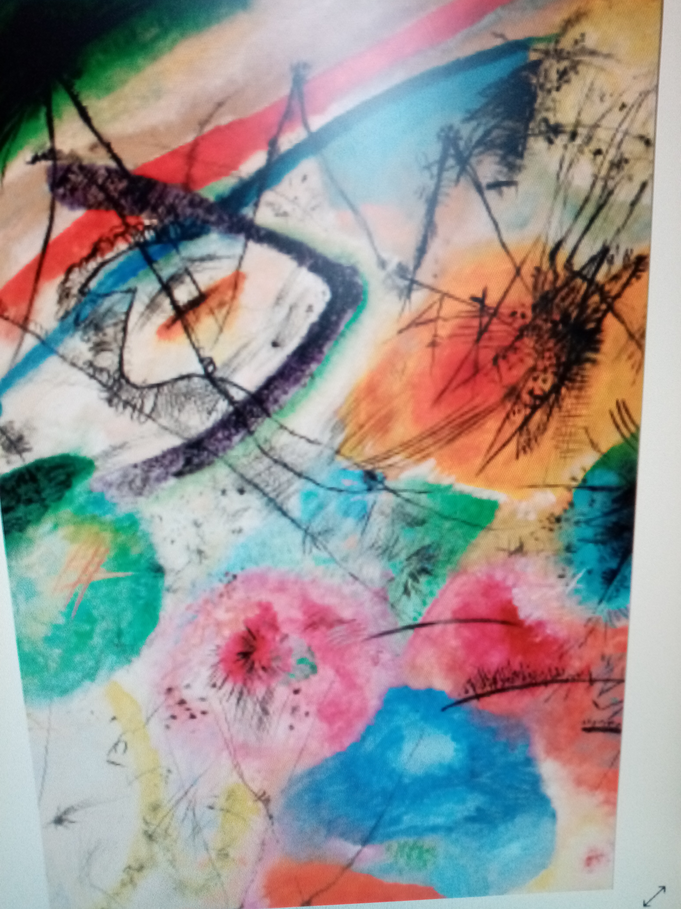

2 This artist Kan do anything he is very skilled.
What's his name and nationality?

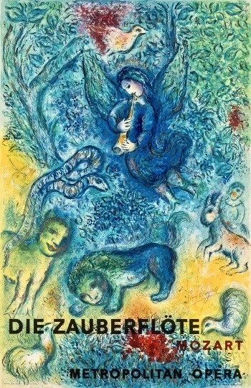

3 The Magic Flute, shown here, was painted by which artist ?
He definitely made his mark .

4 When and where would you use a Set Square?

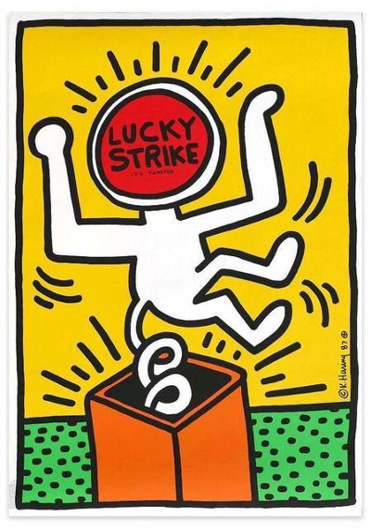
5 If we had any doubts, before our visit, we were all won over by the talk at Tate Liverpool
on this controversial hairy artist, who is he ?

6 What is a Mahl Stick used for, also what's the best size ?

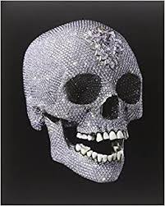

7 Title of this work by Damien Hurst please?…………….

8 What are the five most toxic paint pigments, that
were responsible for many artist literally dying for their art?

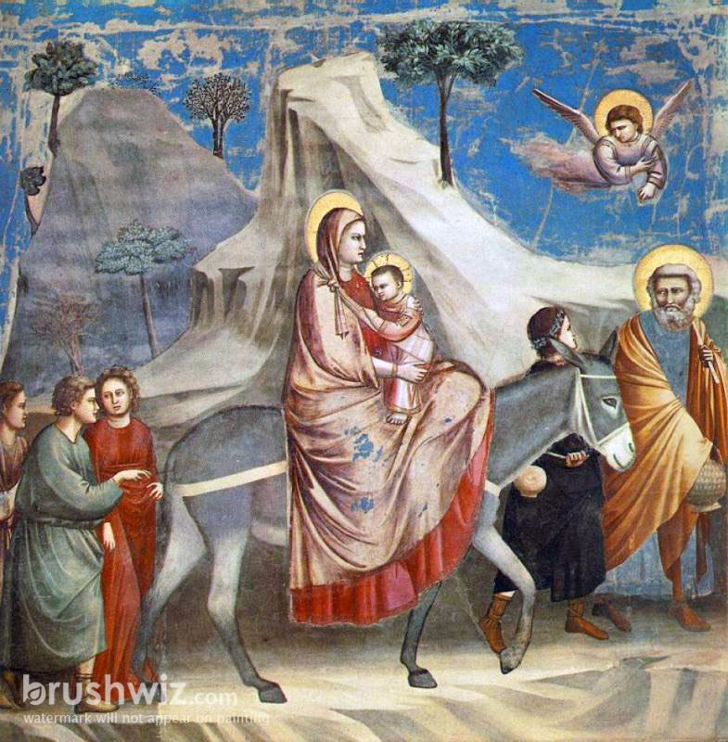

9 This Italian, Religious artist painted
The Flight Into Egypt, can you name him?
I Gotta hand it to him ,its a good un.

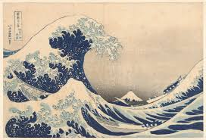

10 Depicted, is one of the most copied woodcuts ever.
I bet we have all received a postcard at some time.
So no subtle hint here.

Title and artist name please?

