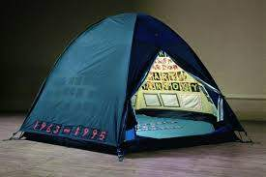
Art Quiz October 2nd

1 Who said Everyone I have ever slept with?

2 What were Lowry's Christian names?

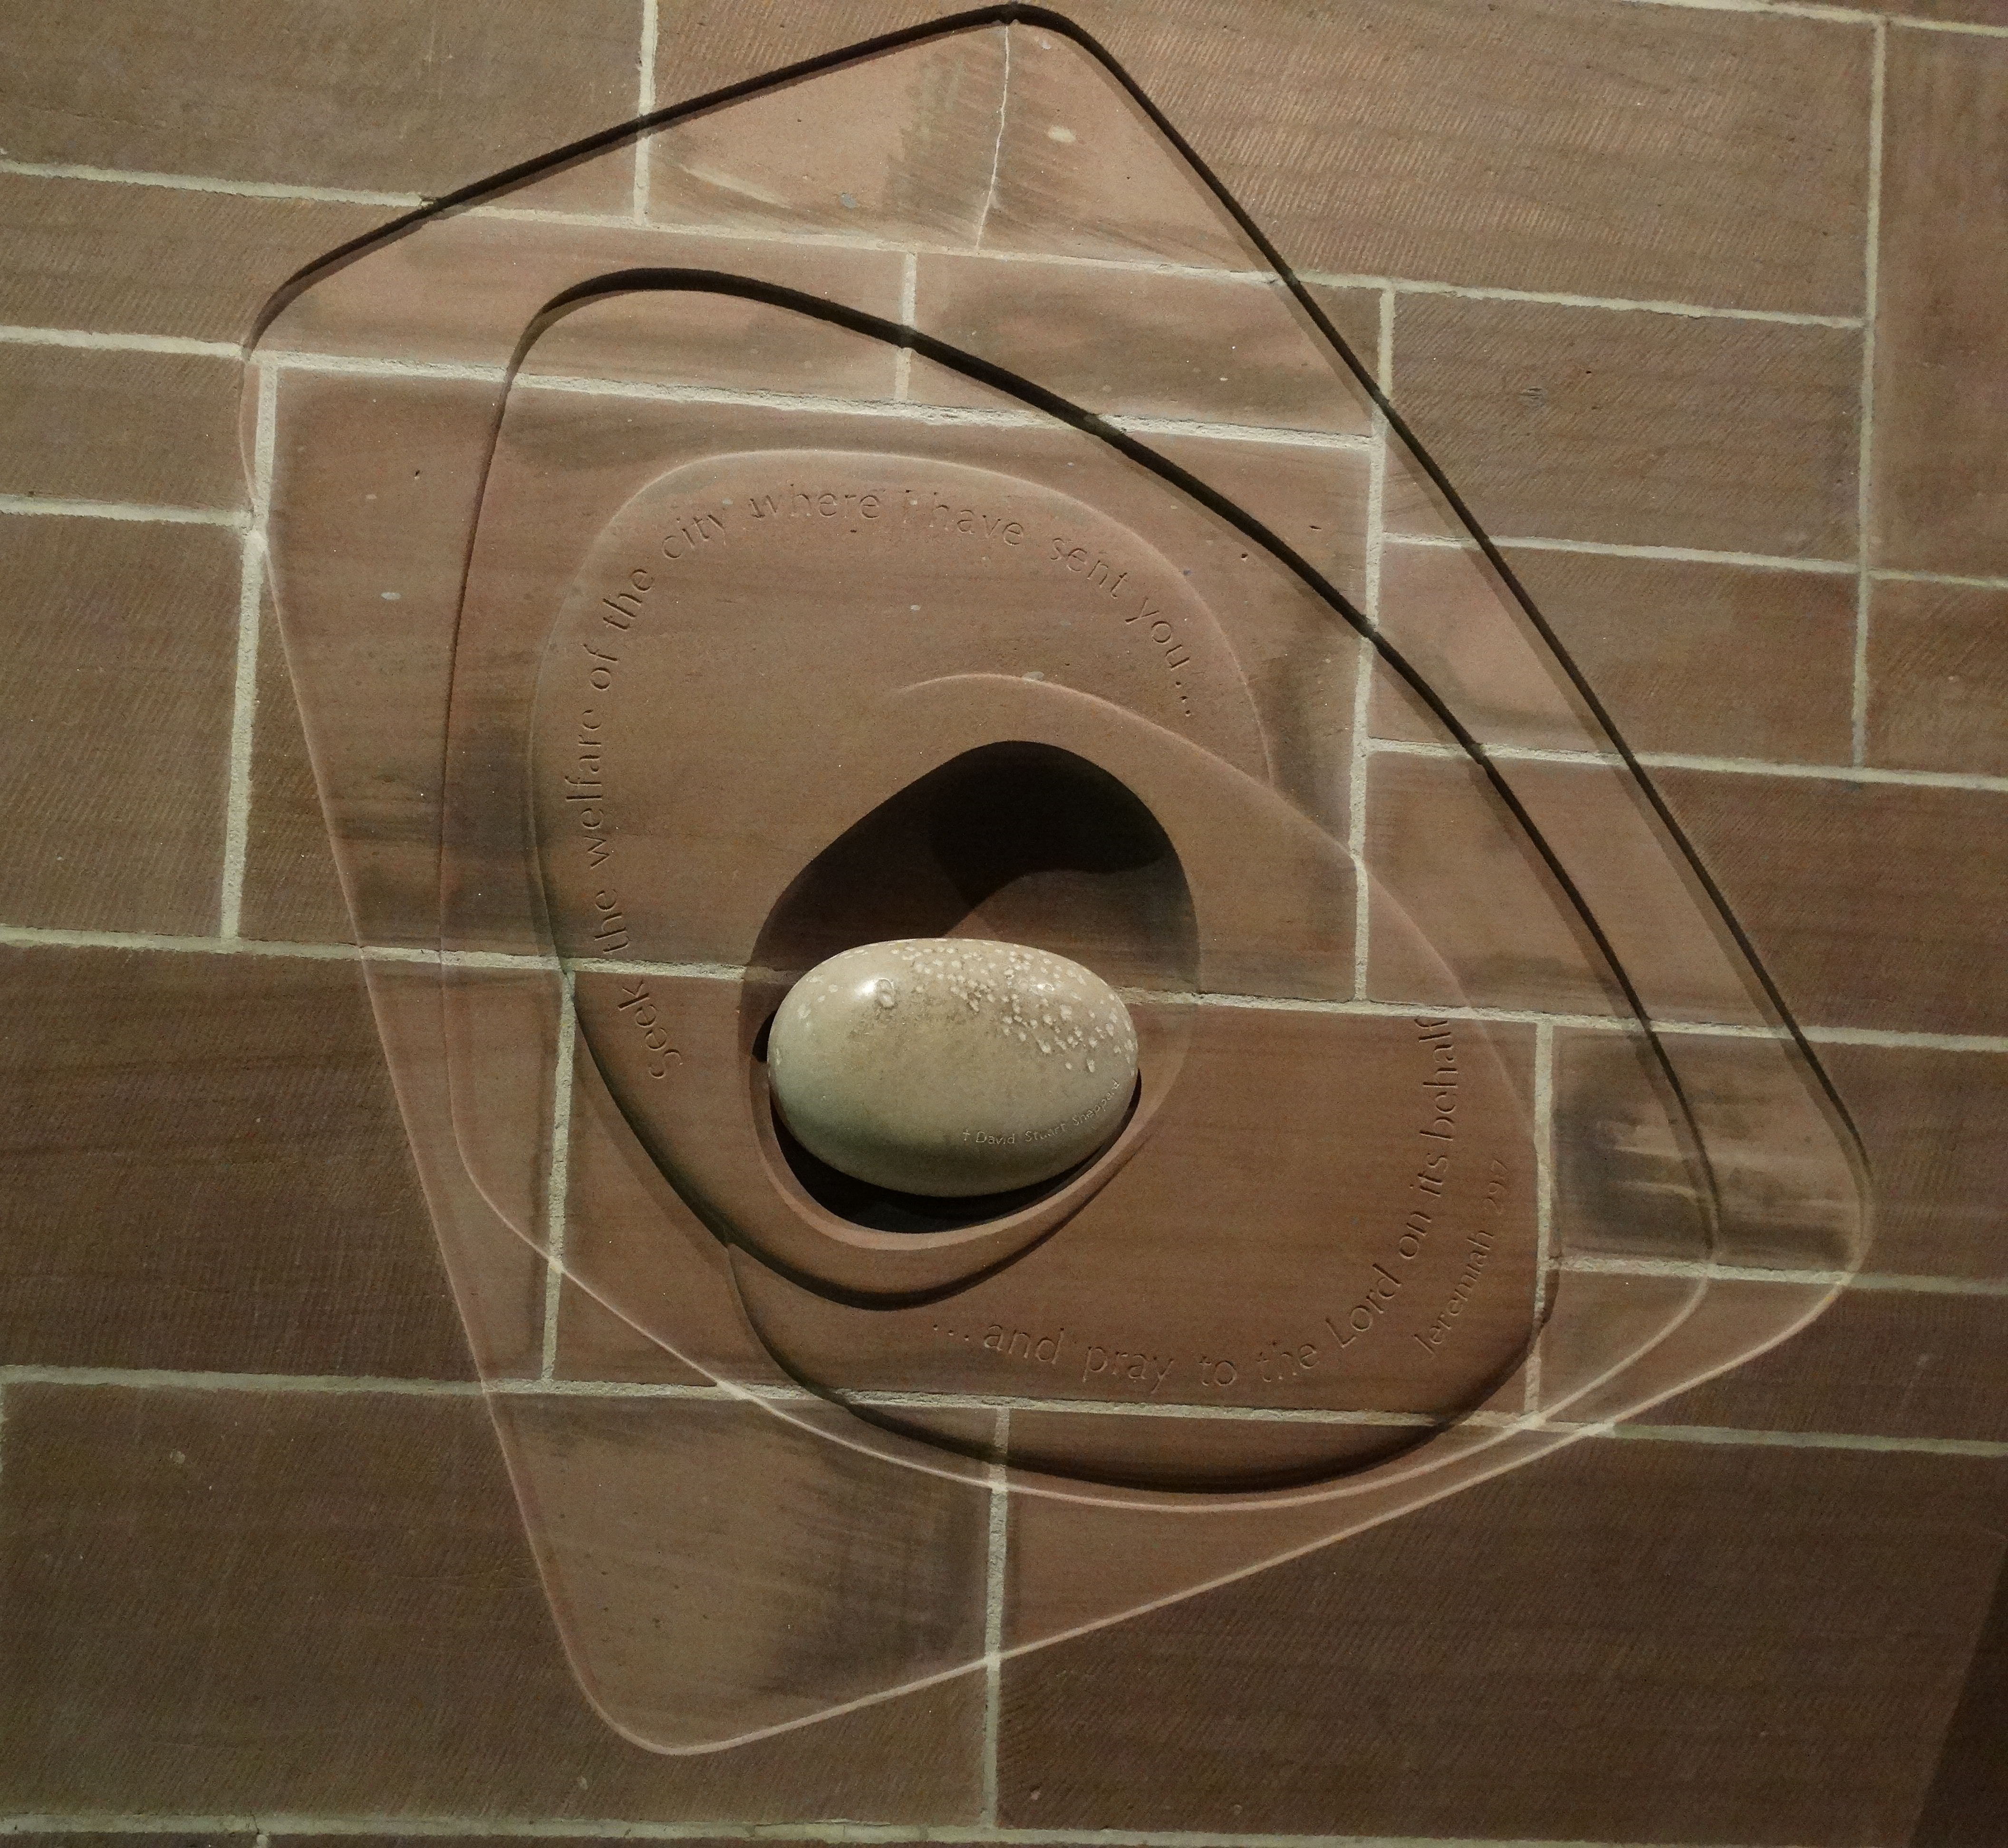

3 In which local, holy place will you find this commemorative plaque?

4 What dose a fresco art mean?

5 Which famous artists house did we visit in Glasgow on our groups first visit?

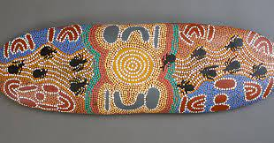

6 What is the term for this art genre?

7 Describe a mosaic?

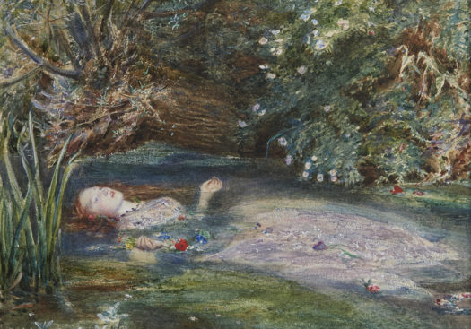
8 What is this painting called and who is it by?

9 What is meant by the termArt for arts sake?

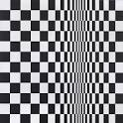
10 Which Female artist gives the spectator a migraine?
Well me anyway!

